Visualizing Music Venues in Toronto’s Boroughs

JR Patton – October 27th, 2020

# Introduction

**Problem Description**

This report will explore the problem of a musician or music lover moving to the Toronto area who is attempting to determine which area (borough) would best give them access to music venues. We will take into account not only venues that exist in the borough but also their average rating to weight the score.

Given this information we will plot the boroughs with a color scale to show which areas may be more appealing to move to.

**Data Description**

For this problem exploration we will use a mix of data from the following sources

1. A list of postal codes and associated boroughs and neighborhoods scraped from the following [wiki page](https://en.wikipedia.org/wiki/List_of_postal_codes_of_Canada:_M), omitting any values that do not have any assigned borough
2. The above info will be merged with a list of locations (longitude and latitude) provided by the geocoder library
3. The Foursquare API will be leveraged to pull a list of music venues in each of these locations along with their average rating so that they can be weighted

# Methodology

To begin with, data was pulled from the Canadian List of Postal codes: M wiki page into a dataframe using the requests and beautifulsoup libraries respectively to query and scrape the data from the webpage. Any postal codes that did not have an assigned borough were omitted and neighborhoods were grouped under the postal code.

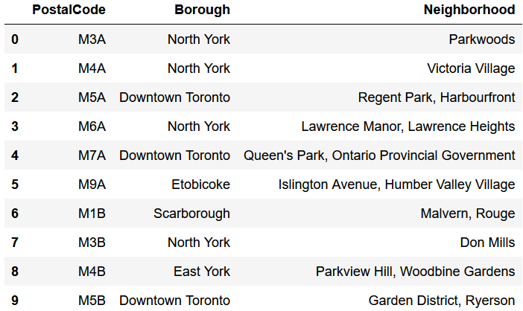

Note that the neighborhood column itself is not used directly for any analysis. In the context of someone looking where to live or visit, knowing the corresponding neighborhoods could provide useful.

This data was then merged with location data of the center of each postal code.

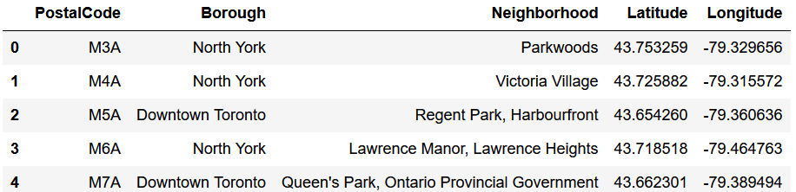

Using this location data, information about surrounding points of interest, in this case “live music” could be gathered. The Foursquare API search for venue endpoint was leveraged for this use case to pull all points of interest (POI) in a circle centered at each borough and with radius of 1000 meters. Each of these POIs was then run back through the details of venue Foursquare API to attempt to retrieve the user rating.

The POI rating was used to give each a score based on the following guidelines. These scores were then tallied up to give the borough it’s music score which was merged back into the original data fram

- 1 points: venue has an average Foursquare rating less than 4

- 2 points: venue has an average Foursquare rating between 4 and 6.5 or has no rating

- 3 points: venue has an average Foursquare rating between 6.5 and 8.5

- 4 points: venue has an average Foursquare rating greater than 8.5

# Results

The scores from the analysis above was then plotted using a folium map using the libraries colour and branca to add color to the markers and a legend. As shown by the legend, those boroughs with color markers of the light sky-blue color have a lower music score and those nearer to dark red have a higher score

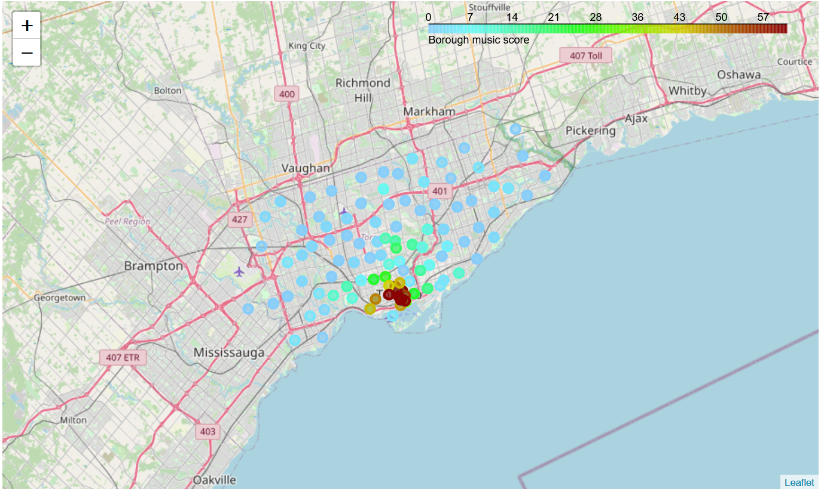

# Discussion and Conclusion

Looking at the map and the dataframe, we can conclude that the best place to if you were a musician or music lover would be the Downtown Toronto borough and corresponding postal codes (M5X, M5H, M5G, etc.). This area sees not only a higher concentration of venues but also those that are ranked higher by users.